
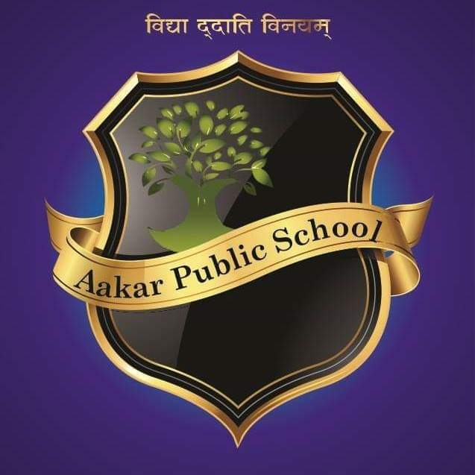

MONTHLY PLANNER FOR AUGUST
CLASS VI

S. NO. | SUBJECT | TOPICS TO BE COVERED | ACTIVITIES
1 | English | Honey Suckle: - Taro’s Reward  Poem- A Kite  A Pact with the Sun: - A Friendly Mongoose | Dictations based on chapters, poem recitation
2 | Hindi | हिंदी रिमझिम- पाठ-5 अक्षरों का महत्व  पाठ-6 पार नजर के  व्याकरण वाटिका- पाठ-3 संधि  पाठ-4 शब्द विचार  पाठ-5 शब्द भंडार  बलराम कथा- पाठ -1 अवधपुरी में राम  पाठ -२ जंगल और जनकपुरी | 1.चित्र कथा  2. शब्द सीढ़ी आगे बढ़ाना
3 | Mathematics | Ch-3 Playing with numbers  Ch-4 Basic Geometrical Ideas  Ch-6 Playing with numbers | 1.Rapid fire of factors and multiples.  2.Circle of Primes and Composite Numbers.
4 | Science | Ch-5 Separation of substances  Ch-6 Changes around us  Ch-7 Getting to know plants | 1.Demonstrate Separation method and viva on related topic.  2.Identify the changes that can or can not be reversed.
5 | Social Science | Geography-Ch-1 Our Earth in the solar system  Ch-2 Globe Latitude and Longitude  Civics- Ch-3 Key elements of democratic government. | 1.Discussion about Solar System in the Class.  2. Fill continent in World Map.
6 | Sanskrit | रुचिरा:- चतुर्थ: पाठ --विद्यालय:  पंचम पाठ – वृक्ष: | 5 पक्षियों के नाम एवं  किन्ही 5 वस्तुओं के नाम लिखी !

Periodic Test
22nd August – 26th August – Periodic Test I

Workshops:
06/08/2022 :- Rakhi Making & Election for School Captains
20/08/2022 :- Best Out Of Waste Workshop

Holiday List:
9th August – Moharrum/ Adivasi Diwas
11th August – Rakshabandhan
13th August – Second Saturday
19th August – Janmashtami
27th August – Fourth Saturday

